Guided Capstone Project Report

Big Mountain Resort Ticket Price Modeling

**The Problem**

Currently, Big Mountain Resort (BMR) sets ticket pricing at a premium above the average price of resorts within its market segment. This approach, however, does not take into account the pricing power leveraged by the existing facilities, and offers little business intelligence to management regarding potential revenue increases from future improvements to the existing facilities.

**Market Analysis**

To address this, an analysis of 36 key features at 277 national ski resorts within BMRs market segment was conducted to accurately quantify a ticket pricing scheme based upon the pricing power of BMRs facilities relative to the national market. Features in this context include ski resort attributes likely to influence ticket pricing, for a set of the features used in this analysis see Figure 1.

**Insights from Modeling**

Adult weekend daily ski pass price was selected as the target variable for regression model development due to data completeness. A linear regression model (LRM) and random forest regression model (RFRM) were trained on the national ski resort dataset to evaluate relative feature importance with regard to adult weekend daily ski pass price. Cross validation of model performance indicated lower mean absolute error (+/- $9.55) from the RFRM relative to the LRM (+/- $11.79) when estimating ticket pricing, therefore the RFRM model was selected for use.

Results from ski resort feature importance indicate that four dominant features influence ticket pricing nationally (Figure 1):

1. Number of runs
2. Number of fast quad lifts
3. Acreage covered by snow making machinery
4. Total vertical drop as calculated from the highest lift-served point to the mountain base

Figure 1. RFRM feature importance analysis conducted on the national ski resort dataset. Note the high importance metrics for ‘Runs’, ‘fastQuads’, ‘Snow Making_ac’, and ‘vertical_drop’.

Fortunately, BMR compares well relative to its market peers with regard to the top important facilities, possessing a significantly above average number of runs, fast quads, skiable terrain area, and vertical drop, while listing ticket prices at only slightly above market average (Figure 2).

Figure 2. BMR position relative to market segment peers for features important to ticket pricing.

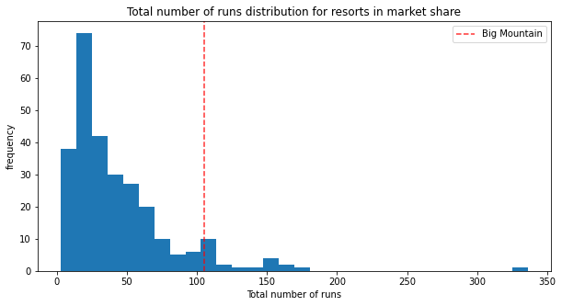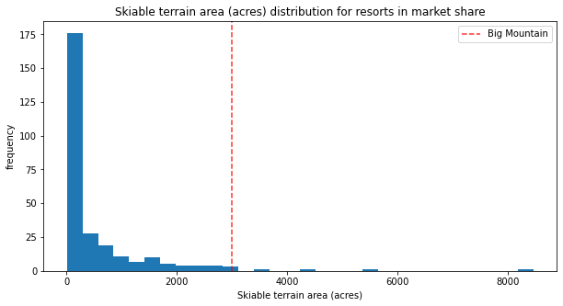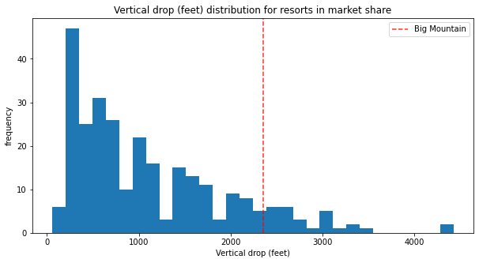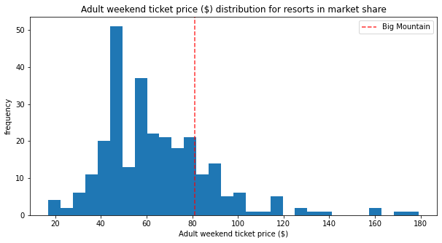

Specifically, modeling suggests that BMR facilities can currently support a ticket price of $92.83/day for an adult weekend ski pass assuming no improvements to the current facilities. This is an increase of 14.6% over the current $81.00/day rate, yielding an additional $20.7 million in annual revenue assuming 350,000 expected visitors.

**Recommendations**

Based upon BMR managements desire to optimize ticket pricing to increase revenue, while allowing for operating cost reduction, the following actions are recommended:

1. Optimize ticket pricing based upon current features: Increase weekday and weekend ticket prices from $81.00/day to $92.00/day as supported by current resort facilities. The ticket price increase will generate a net revenue increase of $19.25 million/annum. Use increased revenues to fund construction of feature additions discussed below.
2. Add features to support further revenue increases: Increase vertical drop by 150 feet via the addition of one run to a point 150 feet lower on the mountain. Service the added run with one new chair lift, which will increase operating costs by $1.54 million/annum. Upon completion of these features, implement the new model-supported ticket price of $102.00/day, which will generate a gross $17.67 million/annum revenue, a net revenue increase of $16.13 million/annum.
3. (Optionally) Close 1 run to reduce operating costs: If deemed necessary, operating costs may be reduced through closure of 1 run at the expense of no annual revenue. See Figure 3 for modeled annual revenue loss as a function of ski run closure.
4. (Optionally) Close 3-5 runs to reduce operating costs: If further operating cost reduction is deemed necessary, closure of up to 5 runs is suggested, which will result in a loss of $1.0 million in annual revenue (Figure 3).

Figure 3. Modeled annual revenue loss and ticket price delta as a function of run closure at BMR. Note that revenue losses are equal for 3-5 run closures.